**HOSTEL MANAGEMENT SYSTEM**

A Mini Project

Submitted by

Sumit Jain (Roll No. 049)

Siddhant Dharmatti (Roll No. 048)

Prem Vohra (Roll No. XXXXXXX)

Rupak Ganphati (Roll No. XXXXXXX)

THIRD YEAR COMPUTER ENGINEERING



Department of Computer Engineering International Institute of Information Technology

Hinjawadi, Pune – 411057

SEMESTER I (AY 2020-21)

**TABLE OF CONTENTS**

|  |  |
| --- | --- |
| **TITLE** | **PAGE NO.** |
| 1. ABSTARCT | 1 |
| 2. INTRODCUTION |  |
| 2.1 SCOPE |  |
| 2.2 REQUIRMENT ANALYSIS |  |
| 2.3 SOFTWARE AND HARDWARE DETAILS |  |
| 2.4 LIBRARIES / PACKAGES USED |  |
| 3. DATABASE DESIGN |  |
| 3.1 DATA MODELING (E-R DIAGRAMS) |  |
| 4. GRAPHICAL USER INTERFACE |  |
| 5. SOURCE CODE |  |
| 6. TESTING DOCUMENT (TEST CASES) |  |
| 7. CONCLUSION |  |

***Details of fonts/styles to be used and others are as below:***

* *The size of the paper shall be standard A4: height 297 mm, width 210 mm.*
* *The standard font shall be Times New Roman with one and a half line spacing.*
* *Title of the Chapter: Normal, Font 16, Bold in Title Case*
* *Main Headings: Normal Font 14 Bold Capital*
* *Subsection Headings: Normal Font 12 Bold Title Case*
* *Paragraphs: Only whenever required, No tabs for paragraphs.*
* *Header – Project Title (left aligned) Footer – Department of Computer Engineering (left aligned) Page No.*
* *Page Margin: Top/Bottom/Right: one inch, left: one and a half each*
* *Do not add blank pages.* ***Avoid*** *blank spaces, too many paragr*

**1. ABSTRACT:**

As the name specifies “HOSTEL MANAGEMENT SYSTEM” is software developed for managing various activities in the hostel. For the past few years the number of educational institutions is increasing rapidly. Thereby the number of hostels is also increasing for the accommodation of the students studying in this institution. And hence there is a lot of strain on the person who are running the hostel and software’s are not usually used in this context. This particular project deals with the problems on managing a hostel and avoids the problems which occur when carried manually.

Identification of the drawbacks of the existing system leads to the development of computerized hostel management system that will be compatible to the existing system with the system which is more users friendly and more GUI oriented. We can improve the efficiency of the system, thus overcome the drawbacks of the existing hostel management system less human error, Strength and strain of manual labour can be reduced, High security, Data redundancy can be avoided to some extent, Data consistency, Easy to handle, Easy data updating, Easy record keeping, Backup data can be easily generated.

**2. INTRODUCTION:**

Hostel Management System is a Software development for managing various activities of the hostel. The Software help user in case of Hostel Information, registration, room and Searching Hostel Account. Aim of the Hostel Management System is to manage the records and make user friendly Software. It helps admin to manage student records, Staff Records and many more. Due to the increase in educational institution Hostel are also increasing for the accommodation.

Hostel management System is online application developed for managing various activities of the hostel. Deals with the problem on managing the hostel and avoided the problem which occur when carried out manually.

**2.1 SCOPE:**

The proposed system for “HOSTEL MANAGEMENT SYSTEM” is computerized. Today is the era of computers. This software project solves all the problems discussed above in the present system. The main objective of developing this project is to save time and money. The proposed system provides the following features on different tasks.

• All the details related to a hosteller could be find in one place like the admission details, fees details, room details , attendance ,mess details, stipend details etc.

• Will make the monitoring of student moment and stock details easy.

• The same application could be used by both the account section and the hostel management for their specific needs and purposes.

It is easy to extend the system that we have proposed. A person could see any of the issued, unissued or all the rooms according to his/her will. In future we can implement some features for “HOSTEL MANAGEMENT SYSTEM” project. In this system its possible to categorize room rent for middle class students and poor students. Some poor students are given a particular concession for the entire year. Even we add a gate keeping feature of in ad out which keeps the record of students going outside of hostel campus and when he/she comes.

**2.2 REQUIRMENT ANALYSIS:**

All possible requirements of the system to be developed are captured in this phase and documented in a requirement specification document.

* **System Design** − The requirement specifications from first phase are studied in this phase and the system design is prepared. This system design helps in specifying hardware and system requirements and helps in defining the overall system architecture.
* **Implementation** − With inputs from the system design, the system is first developed in small programs called units, which are integrated in the next phase. Each unit is developed and tested for its functionality, which is referred to as Unit Testing.
* **Integration and Testing** − All the units developed in the implementation phase are integrated into a system after testing of each unit. Post integration the entire system is tested for any faults and failures.
* **Deployment of system** − Once the functional and non-functional testing is done; the product is deployed in the customer environment or released into the market.
* **Maintenance** − There are some issues which come up in the client environment. To fix those issues, patches are released. Also to enhance the product some better versions are released. Maintenance is done to deliver these changes in the customer environment.

**2.3 SOFTWARE AND HARDWARE DETAILS:**

1. PHP Triad (PHP, MySQL, Apache, and PHPMyAdmin)
2. Wampp
3. HTML
4. Bootstrap
5. Sublime text
6. Git hub
7. Java Script
8. Css
9. OS (windows, linux)
10. Notepad++
11. Visual Studio Code
12. Web Browser (Mozilla, Google Chrome)

|  |  |
| --- | --- |
|  |  |

    

   

**2.4 LIBRARIES / PACKAGES USED:**

**3. DATABASE DESIGN:**

|  |  |  |
| --- | --- | --- |
| Sno. | Entity | Attribute |
| 1 | adminlogin | * id * username * adminpassword |
| 2 | login | * id * FirstName * LastName * MobileNumber * email * password |
| 3 | studentregistration | * Id * Student Name * Parents Name * Student Surname * Email Id * Parents Contact * Student Contact * Gender * Birthday * Address * City * Pin Code * State * Country * Room * Sharing * Mess * Fees Paid * Emergency Contact |
| 4 | Courseinfo | * Id * Course |
| 5 | fine | * Id * FirstName * LastName * Room * Fine * Status |
| 6 | grievances | * Id * FirstName * Emailid * Room * Problem * Status * Flag |
| 7 | manageroom | * Id * Room * Sharing * Floor |
| 8 | Permissions | * Id * FirstName * Emailid * Room * Date of Leave * Date of return * Pname * Relation * Contact Number * Reason * Status * Flag |

**3.1 DATA MODELING (E-R DIAGRAMS):**

A database model is a type of data model that determines the logical structure of a database and fundamentally determines in which manner data can be stored, organized and manipulated.

Level 0

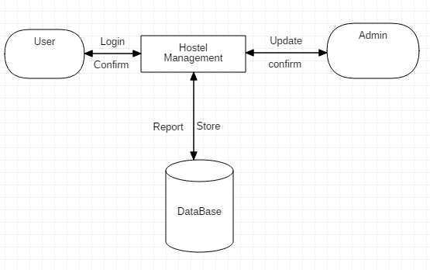

Figure: Data flow

Figure: ER diagram

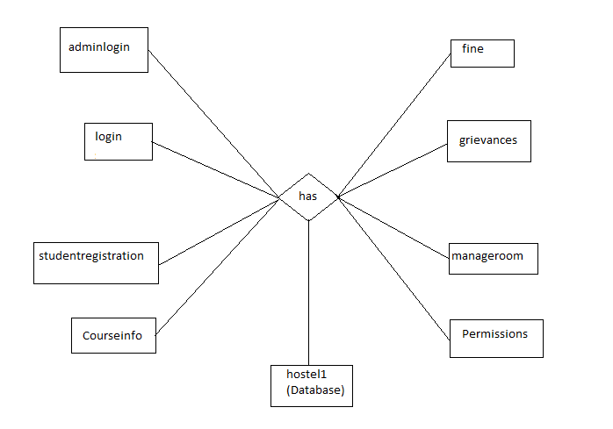

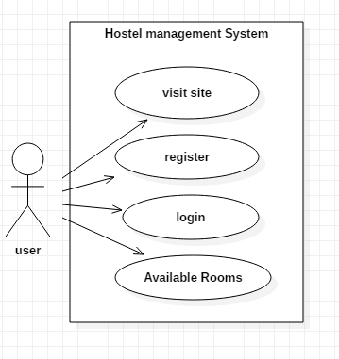Figure: Use case Diagram of Hostel Management System

**4. GRAPHICAL USER INTERFACE:**

**4.1 Student and Admin Login:**

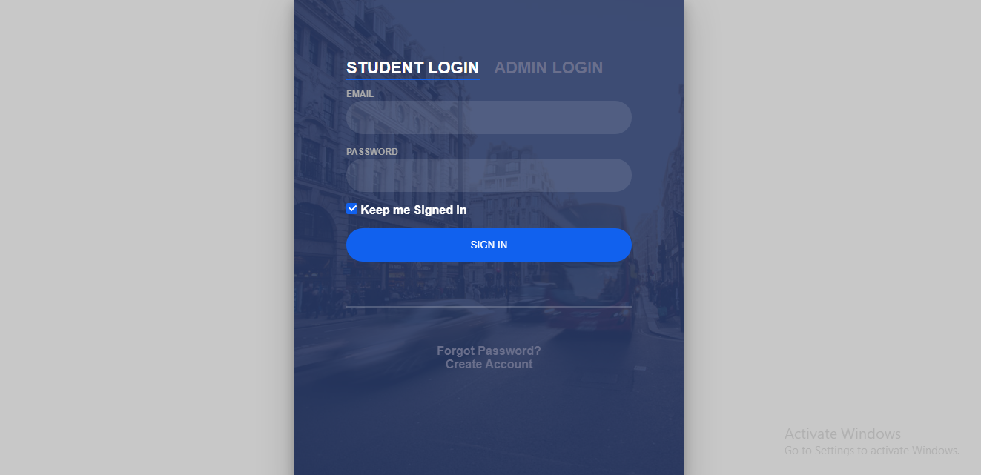

**4.2 Student Login Account Registration:**

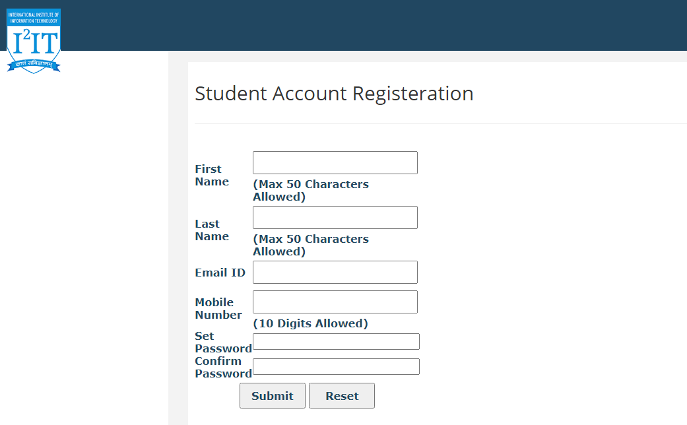

**4.3.1Student Dashboard:**

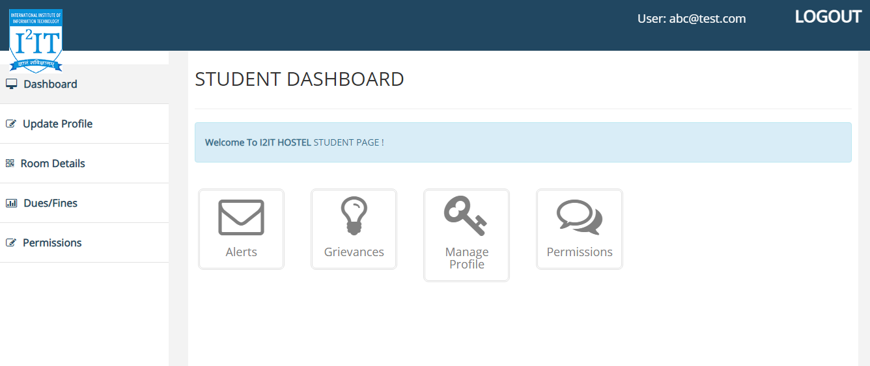

**4.3.2 Student Profile:**

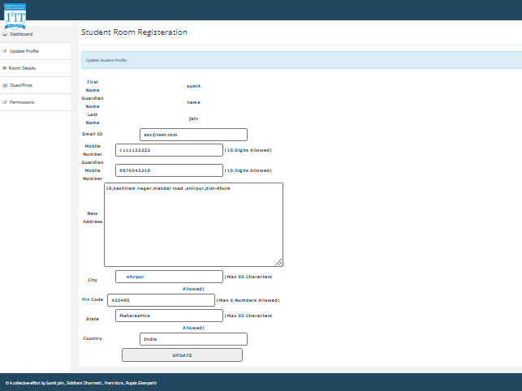

**4.3.3 Student’s Room Details:**

: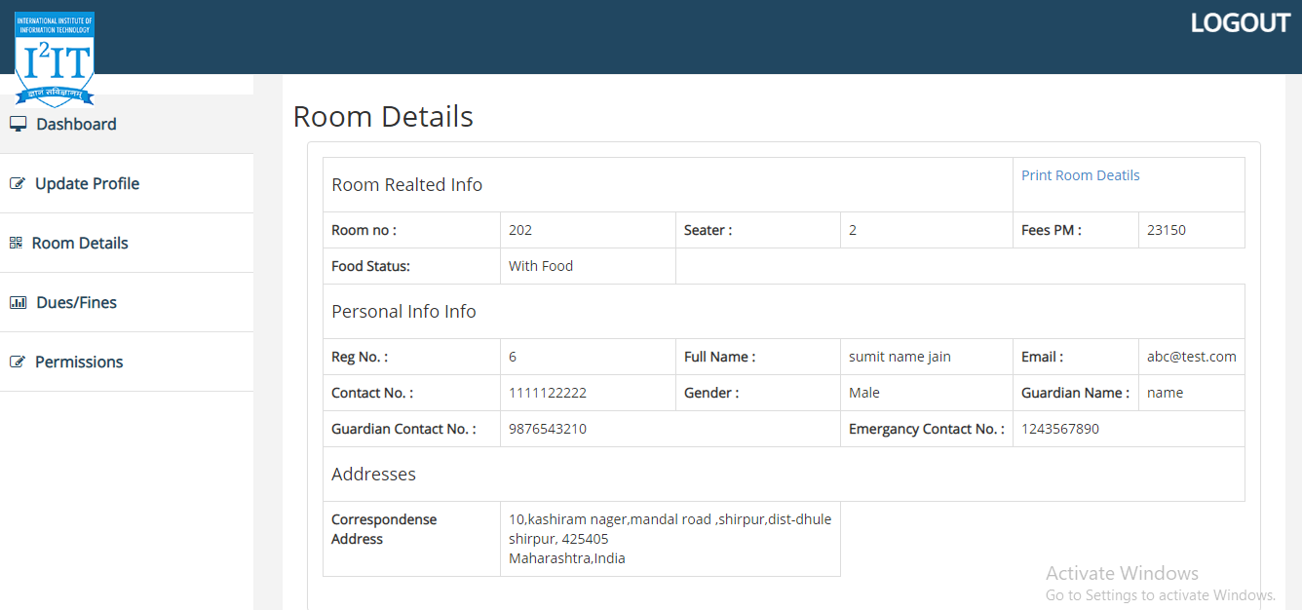

**4.3.4 Students Side Notifications:**

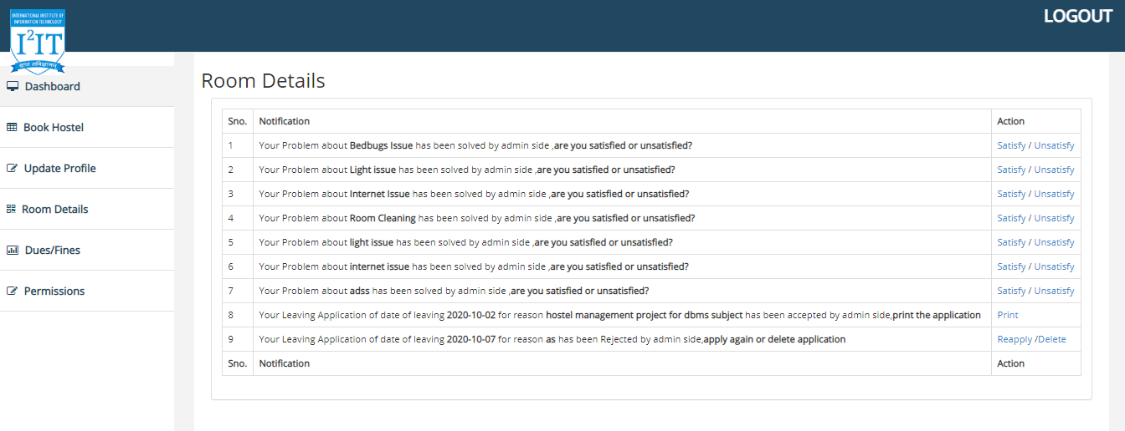

**4.4.1 Admin Dashboard:**

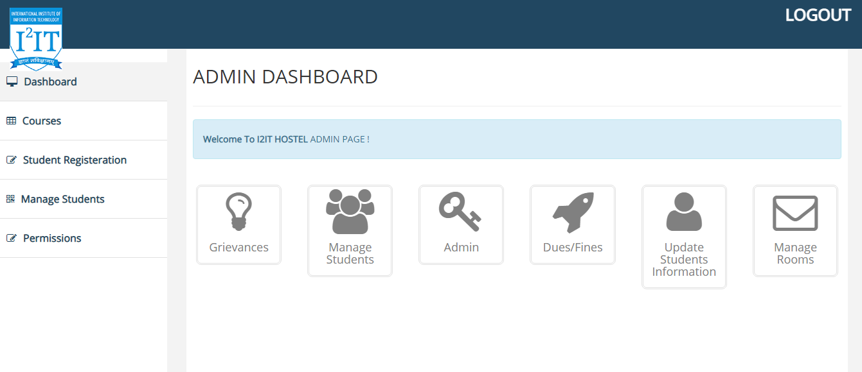

**4.4.2 Courses:**

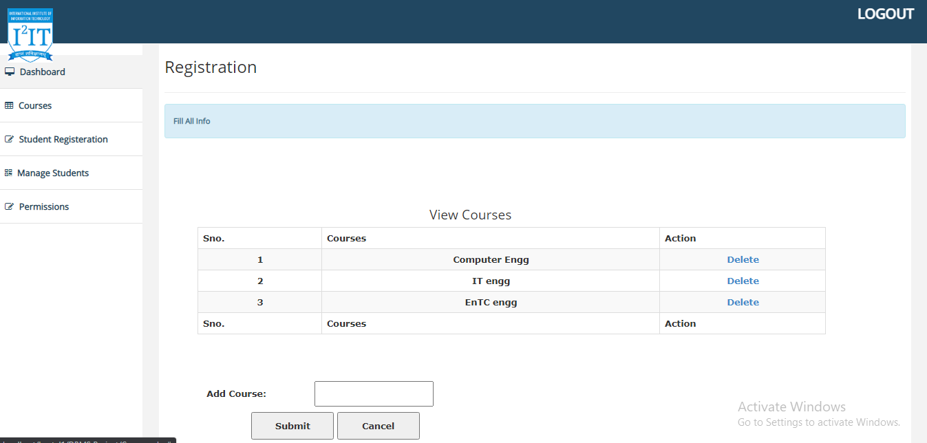

**4.4.3 Student Room Registration:**

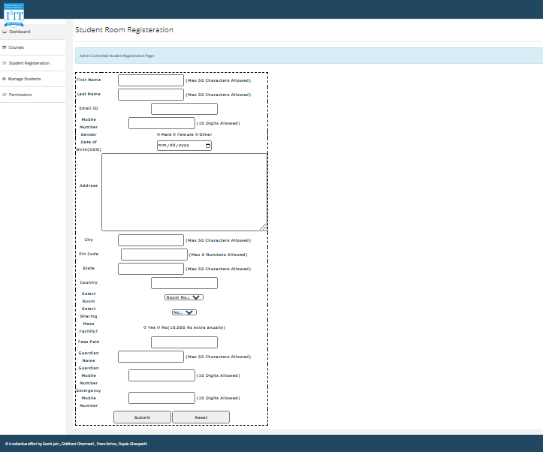

**4.4.4 Students Details:**

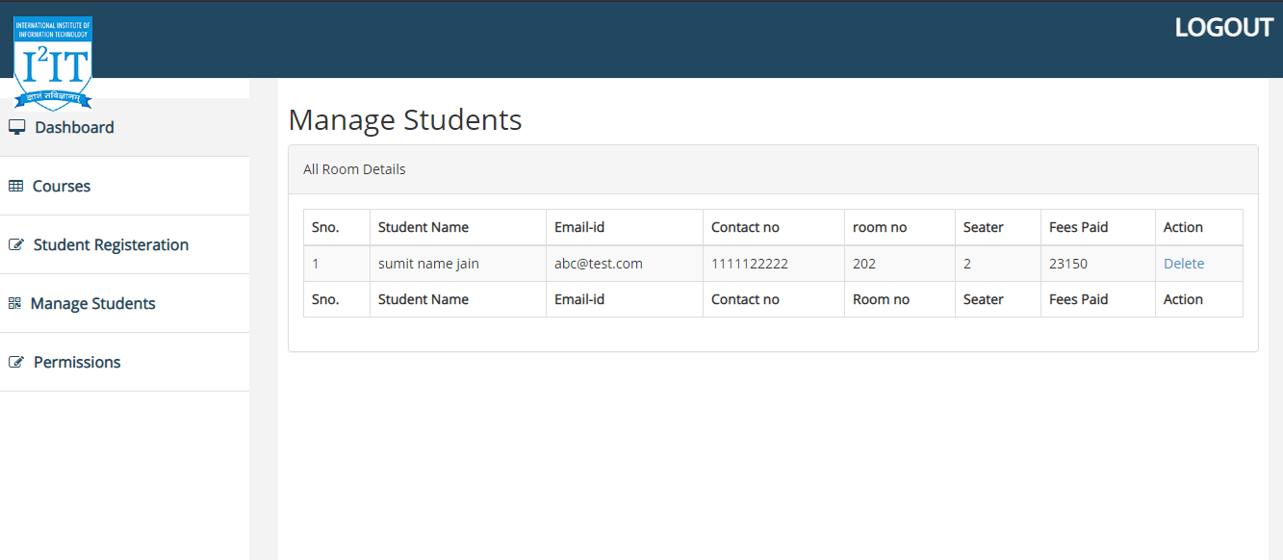

**4.4.5 Students Permission Request:**

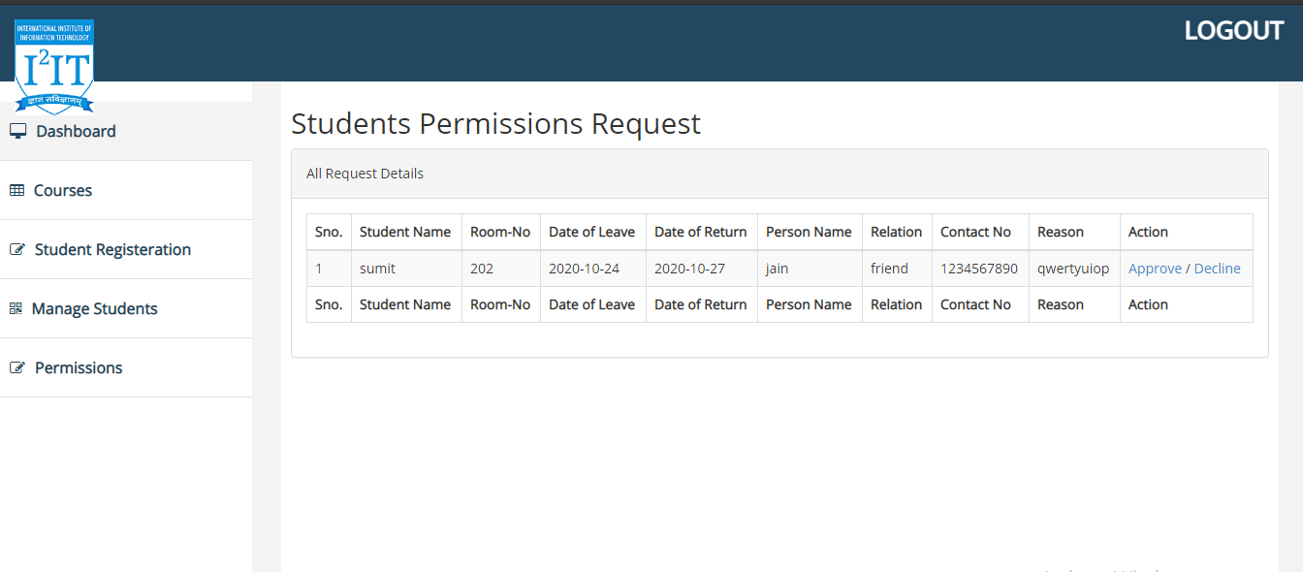

**4.4.6 Grievances Response:**

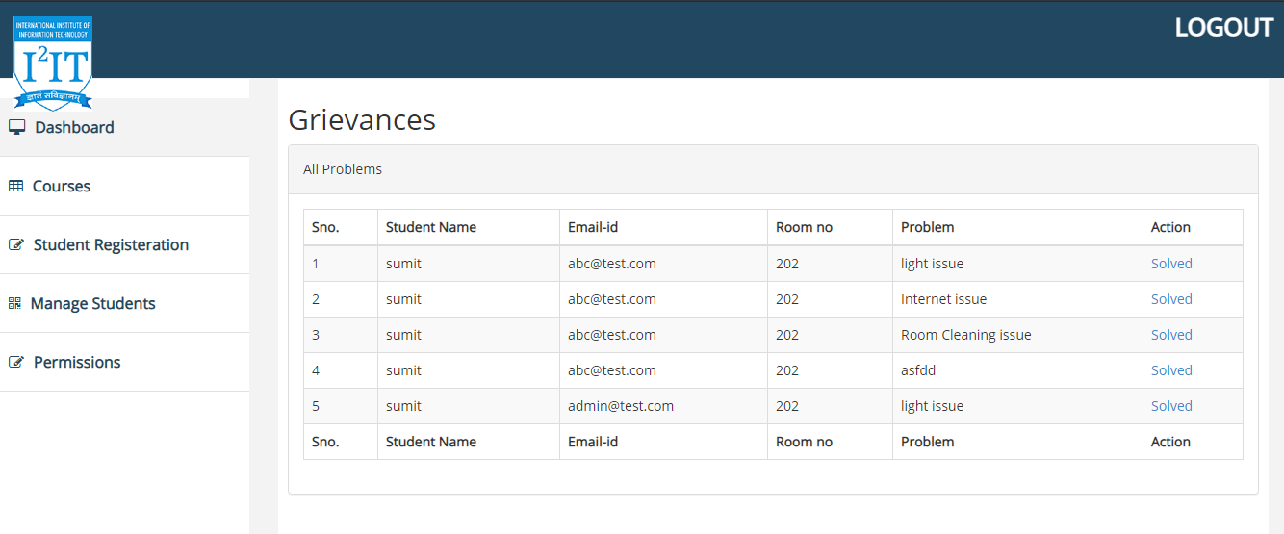

**4.4.7 Manage Rooms:**

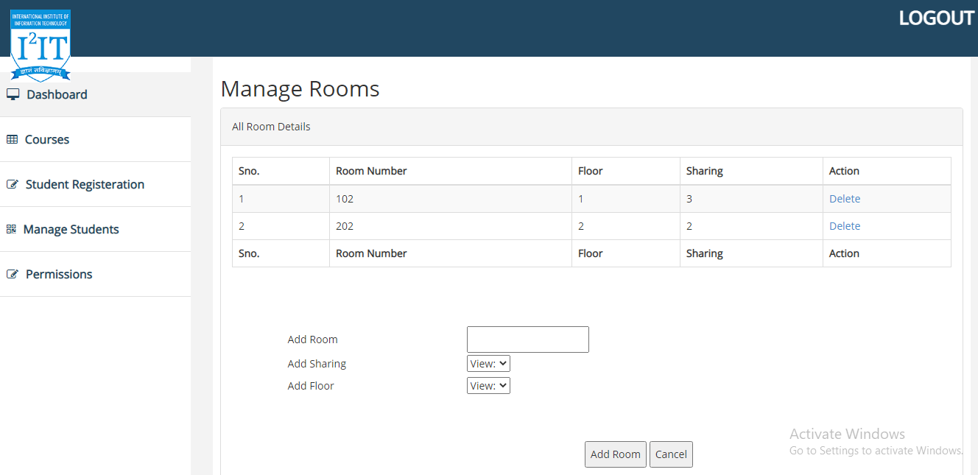

**5. SOURCE CODE:**

Call.php

<?php

include'config.php';

include'connect.php';

include 'helperfunction.php';

include 'adminfunctions.php';

include 'roomfunction.php';

include 'studentfunction.php';

include 'userfunction.php';

Config.php

<?php

define('SERVER','localhost');

define('DBUSER','root');

define('DBPASS','');

define('DBNAME', 'summerproject');

Connect.php

<?php

$servername=SERVER;

$dbname=DBNAME;

try {

$conn = new PDO("mysql:host=$servername;dbname=$dbname", DBUSER, DBPASS);

// set the PDO error mode to exception

$conn->setAttribute(PDO::ATTR_ERRMODE, PDO::ERRMODE_EXCEPTION);

// echo "Database created successfully<br>";

}

catch(PDOException $e)

{

echo $sql . "<br>" . $e->getMessage();

}

**6. TESTING DOCUMENT (TEST CASES):**

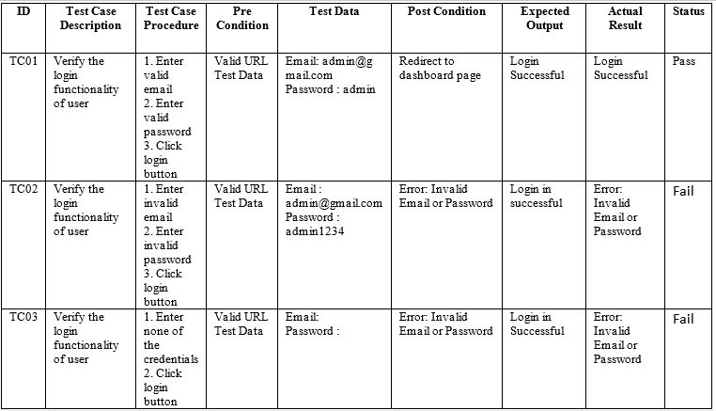

**7. CONCLUSION:**

The project, developed using PHP and MySQL is based on the requirement specification of the user and the analysis of the existing system, with flexibility for future enhancement. The expanded functionality of today’s software requires an appropriate approach towards software development. This hostel management software is designed for people who want to manage various activities in the hostel. For the past few years the number of educational institutions are increasing rapidly. Thereby the number of hostels are also increasing for the accommodation of the students studying in this institution. And hence there is a lot of strain on the person who are running the hostel and software’s are not usually used in this context. This particular project deals with the problems on managing a hostel and avoids the problems which occur when carried manually. Identification of the drawbacks of the existing system leads to the designing of computerized system that will be compatible to the existing system with the system which is more user friendly